Yeshua: The Door and Cross Confusion!
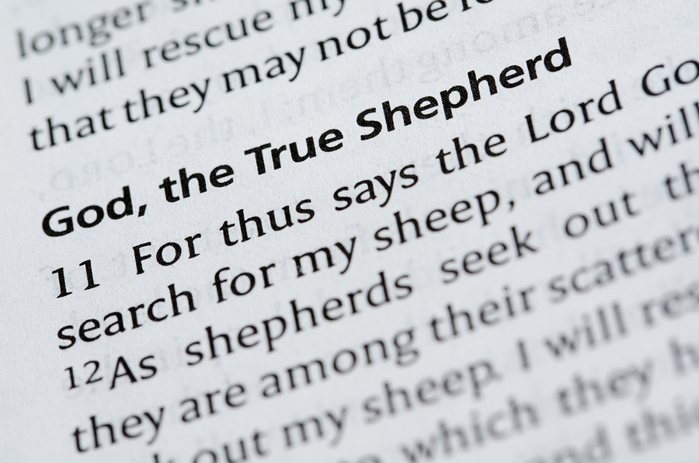

Barbara L.Klika, MSW
Undershepherd
Personal Life Coach
www.set-apart-ministries.org
April, 2019

Then said Jesus unto them again, Verily, verily,
I say unto you, I am the door of the sheep.
John 10:7

Just some brief thoughts:
I was considering the Scripture reference, John 10 about Messiah Yeshua being the Door for the sheep: through which we must all enter to be saved. For many of us who have been believers for some time, we will likely think of the comparisons of the shepherds who protected their flock by herding them into an enclosure with only one opening…the doorway. The shepherd then slept in that doorway, literally becoming the door to the sheep; the door, standing between them and the dangers of the night. We might remember, too, that it is the definite article used-- “the” Door, not just any door. The only way, the truth and the life!

We may remember that sheep are pretty helpless and need constant guidance which may be a reason for the established fact even today that each sheep knows the voice of his shepherd. Even if flocks have been brought together for some reason, each shepherd has only to call and they will divide themselves back into their own flock. As with physical sheep, so is it described to be for “People-sheep” who are following Yeshua, THE Great Shepherd. We know His voice and follow Him!

His reference to Himself as the Door came seven times as recorded in the Book of John. This is the Book that most Christian leaders will recommend that new Believers read first. So, the image of Messiah as a Door is often taken in, early on in our faith walk. When we have grown a bit more in our ability to study and parse out the text, we see that this description being recorded seven times also carries a sense of the completeness and finality of this message!

Yet, traditional Christian theology often focuses more on the cross as the best picture of what He did for us. Many hymns center on the cross; much theology centers on the cross......but in truth, it was an instrument of torture that the Roman's used...not a Hebraic picture that is rooted in the Scriptures themselves.

Most Believers have heard at one time or another that Messiah Yeshua, Jesus, is our Passover Lamb so they can make some connection with the first Feast. But there is so much more! There is a Door picture that ties this all together!

Here is one more portion of the fullness of what it means for Messiah to be our Door as well as both the Lamb Who was slain before the foundation of the world was laid, AND our Great Shepherd!

When we recall that the Passover picture involved the sacrifice of the innocent lamb, and putting the blood on the door posts of the home, and then staying in that home, while the Angel of Death "passed over"...I think we are seeing a great revelation of what was to come. Yes, Yeshua Messiah is the Passover Lamb that was foreshadowed by the lamb's sacrifice for the first Passover. It is His shed blood that was symbolically represented by the lamb’s blood put on the doorposts. How much more do we see the fullness of what the little lamb could only symbolically teach! Remember, too, that each person who brought a lamb for a sacrifice for sin didn’t just drop it off at the Temple for the priests to slaughter! No, they had to hold the lamb, and place their hands on the head of the lamb, symbolically transferring their sin to the innocent lamb, as it was slaughtered. “I lay my sins on Jesus,” the old hymn says-- and now I know why!

His blood was shed for our restoration/salvation...and when we stay "in the house" which is a Hebraic metaphor for being in the covenant of Torah, the Father's house, that is where our security and salvation is found! The angel of death will pass over those who are under the covering of Messiah’s shed blood, and who stay inside THE Door of the fold!

And the threshold of the door post represents the threshold covenant that we have through our acceptance of His work on our behalf. We remember that the Passover remembrance is a covenant gathering, for those who have come under Messiah's shed blood and into the Father's House! It is for those who have allowed themselves to be “set apart” for and by His purposes, no matter what their heritage; by faith grafted in and permitted to join with the family of Yah in His House.

So, what happens when traditional Christianity focuses on the cross instead of the door theme? Confusion, and loss of focus on God’s plan.

This confusion between cross and door could be said to be an outcome of not letting Scripture interpret Scripture, but instead reading into it. Rather than pointing back to the original Word, historical current events and a leader’s image were chosen to represent what Messiah did for us.

By “pointing back” I am referring to the recognition of the patterns and themes that our wonderful Creator has placed within the Written Word, from the beginning all the way to the end, to help us better understand His Name, His character and His plan for us all. Rather than looking back to see if there was an earlier picture that had to do with shed blood and covering…the parallels between what they knew to be the Passover Feast with the sacrifice of the innocent lamb to save the people, and the shed blood and covering that THE Lamb of God accomplished on our behalf—they went with what was presented to them by a leader and conqueror.

The veneration of the cross seems to have involved a blending or borrowing of the Mystic Tau of Chaldeans or Egyptians...and there was also the influence of Constantine's dream in 312 before the battle of Milvian Bridge, which allegedly confirmed his Christianity, while also invoking the symbol of cross, involving a sign in the heavens. There is still controversy over whether or not he was genuinely a Christian Believer for many reasons, among them that he used this pagan symbol of the cross as a mark of God’s work in battle for him, and that the coins minted in his name also carried the phrase soli invicto comit, or “to the invincible sun, companion [of the emperor]. This history isn’t hard to find if you want more background. There is also a great similarity to the Roman religion of Mithra, Mithraism, that seems to blend the teachings of the Bible, about the Son of God, and Mithra, the Sun God.

Taking another angle, the Greek word translated as “cross” is more accurately related to a pole: “stauros” (Strong’s G4716) and not necessarily a pole that had a cross piece attached.

So by referring to the cross, and not identifying it more accurately as a pole, a few things happened.

One: the connection with the first Passover has been missed, contributing to the impression that a whole new religion was created. Veneration of the cross I believe led to the missed significance of the blood of the lambs on the doorposts preserving life for those who stayed in the house, with coming through Yeshua the Door, the Great Shepherd into the Father's House! A thematic link between the OT and the NT was hidden and forgotten.

Two: there is another thematic picture in the Old Testament that refers to the bronze serpent being lifted up on a pole to be a means for the Israelites to look up and be delivered from the poisonous snakes.

And as Moses lifted up the serpent in the wilderness,
even so must the Son of man be lifted up: John 3:14

This, too, was an early picture of Messiah's being lifted up for our salvation. This image is a little difficult at first because the serpent doesn't seem like a worthy metaphor to connect with Messiah, but deeper word study does help us make the connection. So, without understanding that the "cross" was really a pole" traditional Christian interpretation just skips over this, seeing only an OT picture, and missing the thematic connection of the learning that ALL of the OT represents walking after Him so that we learn His ways...in this case, when sin enters in, look up to Yeshua! Just as the sacrifice of lambs and shedding of their innocent blood was a picture, a rehearsal of what Messiah would do for us.

I don't want to speculate on whether this hiding of the connection between the First Feast, Passover and Messiah's crucifixion was intentional or not. I can just say that it has happened, and as a result, "Christians" became even more disconnected from the roots of our Faith...doing exactly what Paul warned us never to do...to boast against the root! it is the same sort of thing that has kept people from realizing the wholeness of the Word, Old and "New" as being all of one piece. It has recently become even more clear to me with in-depth study by Dr. Philip Payne, that it appears to be this same kind of subtle redirection and interpretation that has also skewed our understanding of how YHWH intended both men and women to function in ministry and in relationships. But that is a whole other story!

Does a cross or a door represent more of the fullness of all our Messiah really is? I choose THE DOOR!

www.set-apart-ministries.org (920) 634-2760

